**POLITICAL ALIGNMENT AND PREMARITAL SEX BELIEFS**

By: Percy Brown

20th October 2020.

Is it wrong for a man and a woman to engage in premarital sex? In this article, we analyse public opinion by exploring the relationship between political alignment groups among Americans and their beliefs about having premarital sex, using data on the**premarsx** variable from the General Social Survey (GSS) over almost five decades between 1972 and 2018.

The total number of respondents who responded to this question was 62466. I obtained the responses over time, with the values of each row range between 0 and 1 and displayed the results in a linear graph form. To establish the relationship between political alignment and the **premarsx** variable, I recoded political alignment into three groups: conservatives, moderates and liberals.

**Responses over time**

Here is what the **fraction saying yes** responses by year between 1972 and 2018 look like:

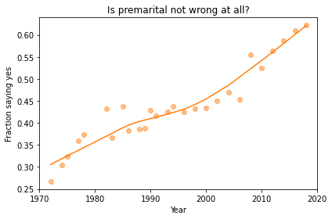

Responses by year to the question “There’s been a lot of discussion about the way morals and attitudes about sex are changing in this country. Is having premarital sex not wrong at all?

The circles in this figure show the observed fractions of responses grouped by year. The lines show a smooth curve computed by local regression.

From the figure above, the number of responses from Americans who think that premarital sex is not wrong at all continuously increased over the period. About 63% of Americans think that having premarital sex is not wrong at all. There was a steady rise of responses claim that premarital sex is not wrong between 1972 and 1990. Since then, the responses that claim that having sex before marriage is not wrong at all have been rising to date. In 1972, about 27% of responses claimed that having premarital sex is not wrong. Fast forward to 2018, we can observe that about 0.7% of American responses thought that having premarital sex is not wrong. What might have caused the increasing views from Americans about premarital sex not being wrong at all?

According to [Premarital Sex the Norm in America](https://www.webmd.com/sex-relationships/news/20061220/premarital-sex-the-norm-in-america), Americans are now waiting longer to get married, hence people are unmarried for longer, than in the past, causing them to have the desire to have premarital sex. The research claims that by age 44, about 95% of Americans have had premarital sex. The public opinion claims that premarital sex is much more common now than in the past.

**Political Alignment**

The following figure shows the **fraction saying yes** responses over time, grouped by political alignment. These responses relate to respondents who self-identify their political alignment as conservatives, moderates, or liberals.

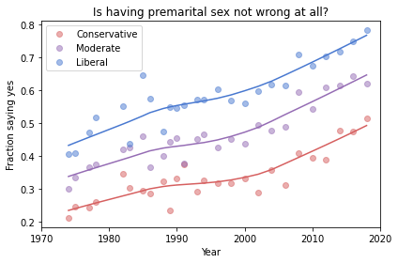

Fraction of respondents who think having sex before marriage “not wrong at all”, grouped by self-described political affiliation.

In the various groups, the number of people who say yes to premarital sex continuously increases at about 20% per decade. Over the period, as expected, liberals are usually more likely than conservatives to think that premarital sex is not wrong, while moderates lie in between them. Self-described liberals have always been liberal in their belief on premarital sex, with their fraction increasing over the decades. Could the fact that conservatives have strong religious values lead to a fewer fraction of them agreeing that having premarital sex is okay?

It is surprising to realise that more conservatives are beginning to think that having premarital sex is not wrong at all over the past few decades. The fraction of “yes” responses from conservatives is currently about 0.5, while liberals constituted about 0.52 in the early 1970s. Currently, conservatives are nearly as liberal as liberals were in the early 1970s.

For more exploration of the “premarsx” variable, visit <https://colab.research.google.com/drive/1W0WY2RWqTCaZ1IRSoBvVmuyMr4XerK9G#scrollTo=qO4TTJsxcM4A>

The modified version of a notebook by Allen Downey is [available here](https://github.com/AllenDowney/PoliticalAlignmentCaseStudy) under the [MIT License](https://en.wikipedia.org/wiki/MIT_License).